Digital Image Processing Exercise Report

Instructor: MITSUGAMI IKUHISA

Student ID: 81322400098

Student Name: GARCIA AARON CALVIN

Date: 2024 04 26

**Algorithm**

Histogram equalization is a technique used in image processing to enhance the contrast of an image. It redistributes the pixel intensities in such a way that the cumulative distribution function (CDF) of the pixel intensities becomes more uniform, meaning the range of intensity values in the image is spread out more evenly. In this example, it turns the images into a more balanced distribution of brightness levels, both visualized in the histogram and the image itself. As a result, areas of the image that were previously too dark or too bright may become more distinguishable, leading to an overall improvement in image quality and visual appearance.

Key things to note:

* Normalize by dividing histogram by total number of pixels
* Original as a gray scale range of 0-255
* Equalized image has a range of 0-1

**Results**

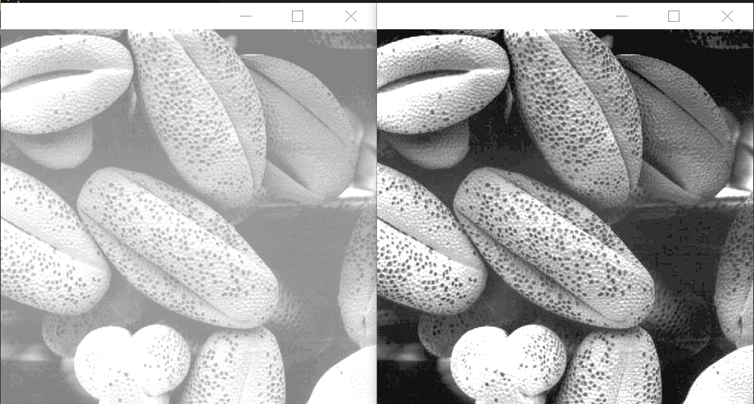

**References**

1. OpenCV Documentation “Histogram Equalization,”   
   <https://docs.opencv.org/4.x/d4/d1b/tutorial_histogram_equalization.html>
2. Rafael C. Gonzalez and Richard E. Wood, “Digital Image Processing,” 2018.